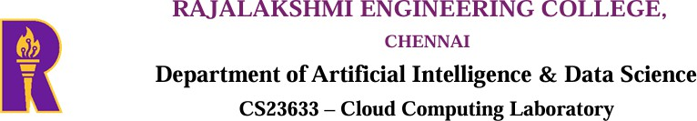

Experiment 2
PAAS in Public Cloud Using Render

AIM
To build a basic Python Flask web application and deploy it on the Render cloud platform. This experiment helps in understanding how a Platform as a Service (PaaS) allows applications to run online without manually setting up or maintaining servers.

What is PaaS?
Platform as a Service (PaaS) is a cloud service that provides everything needed to develop, deploy, and run an application. It takes care of server management, software installation, and deployment, allowing developers to focus only on writing the application.

Why Render?
Render is an easy-to-use cloud hosting platform that supports web application deployment directly from GitHub. It automatically builds and hosts the application, making deployment simple even for beginners.

PROCEDURE:
Step 1
Sign in to your GitHub account or create one if you do not already have an account.
Step 2
Create a project folder named RenderHelloApp.
Step 3
Inside the project folder, create the following files:
- app.py
- requirements.txt
Step 4
Write the Flask application code in the app.py file.
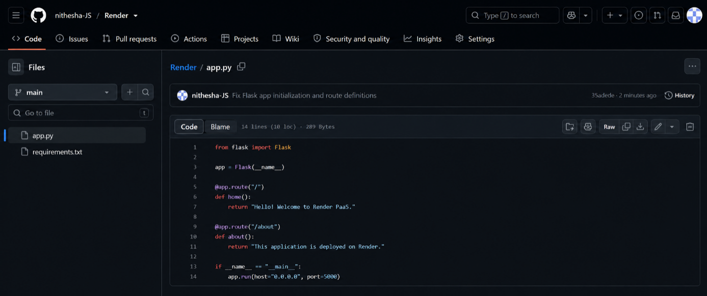

Step 5
Add the required Python packages such as Flask and Gunicorn to the requirements.txt file.
Step 6
Create a new public repository called RenderHelloApp on GitHub.
Step 7
Upload both project files to the repository and commit the changes.
Step 8
Create an account on Render and connect it to your GitHub account.
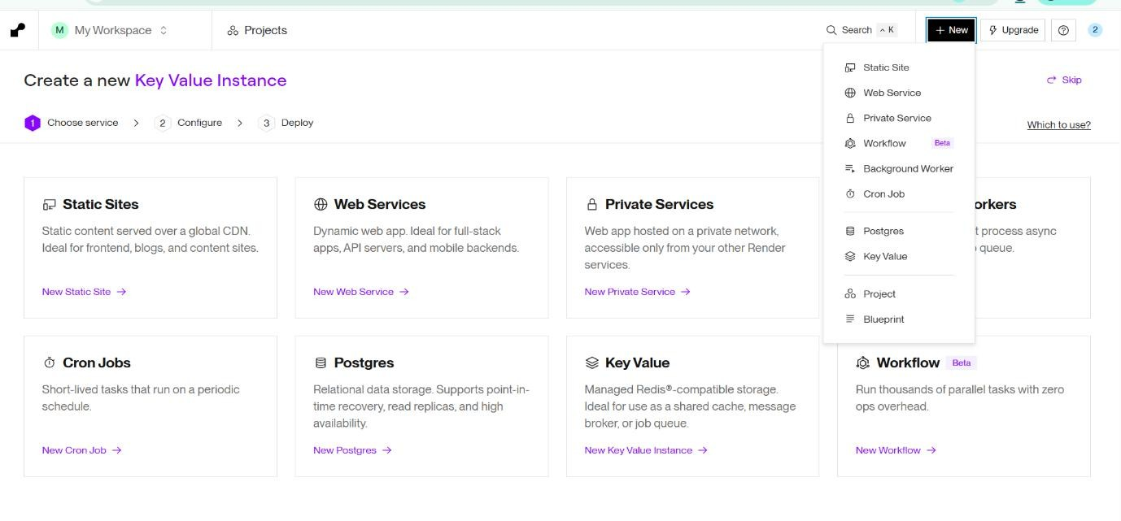
Step 9
Create a new Web Service in Render.
Step 10
Select the RenderHelloApp repository from GitHub.
Step 11
Enter the deployment details:
- Language: Python
- Branch: main
- Root Directory: Leave empty
- Build Command: pip install -r requirements.txt
- Start Command: gunicorn app:app
- Instance Type: Free (if available)
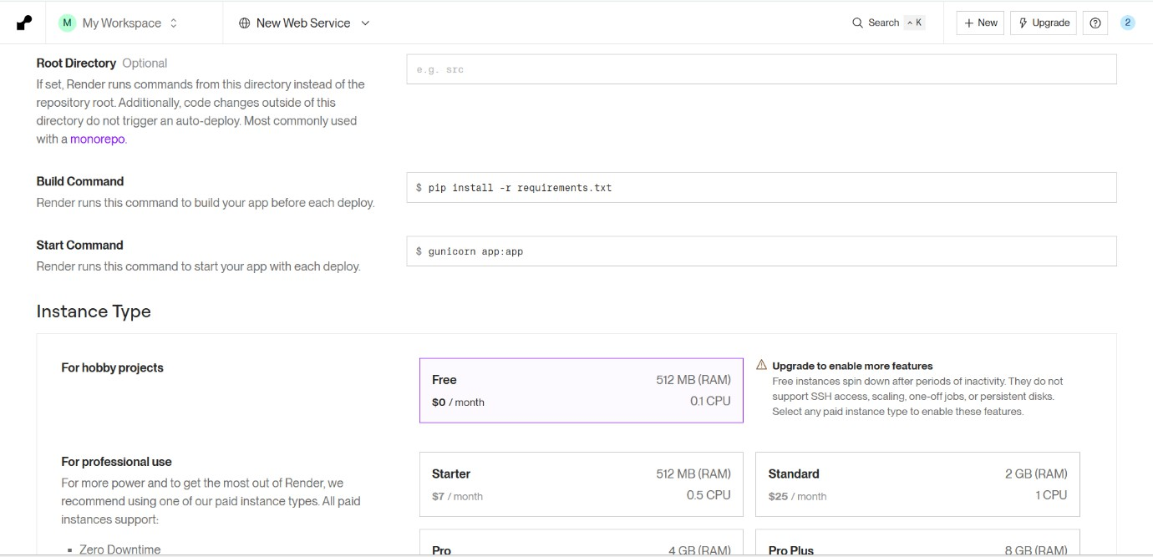

Step 12
Click Deploy Web Service and wait for the deployment to complete.
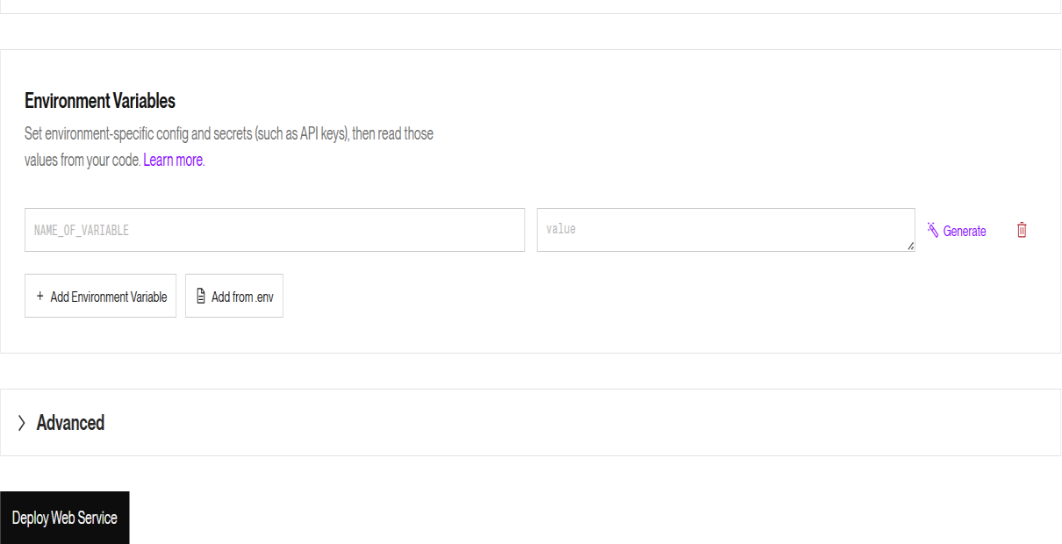

Step 13
After deployment, open the URL generated by Render and check whether the home page is displayed correctly.

Step 14
Add /about at the end of the application URL to verify that the second route is also working properly.
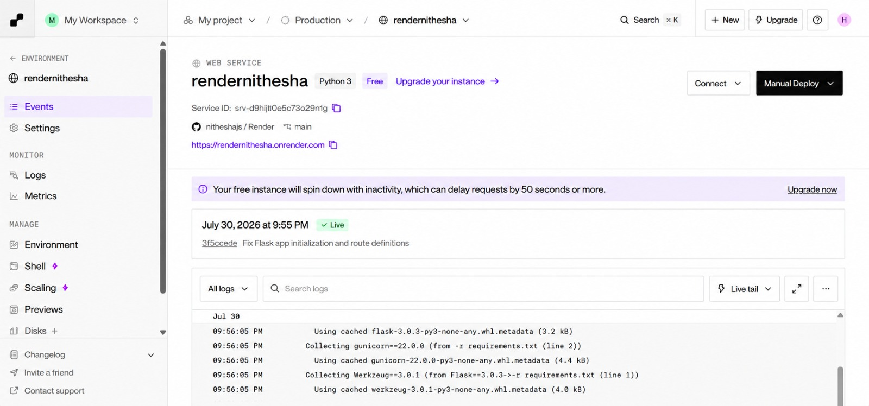

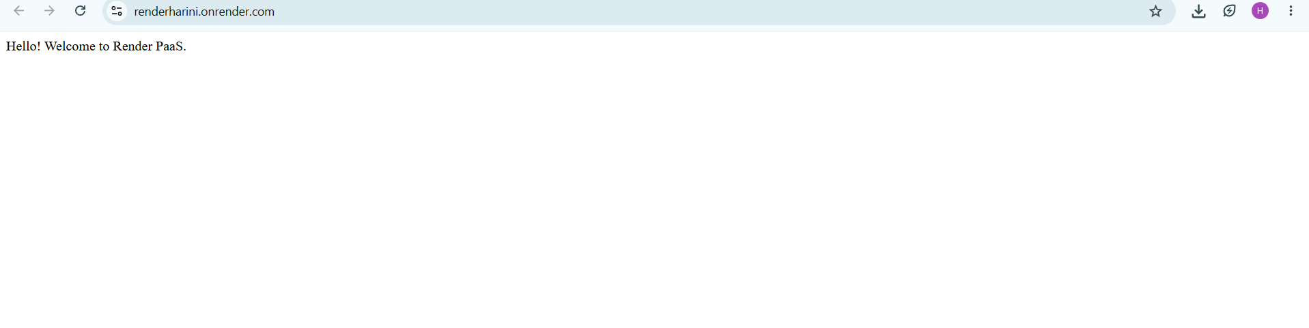

CONCLUSION:
This experiment demonstrated how a Flask application can be deployed using Render, a Platform as a Service. I learned that PaaS simplifies application deployment by handling the server setup and hosting, allowing developers to publish applications quickly without managing infrastructure.

